Curriculum Vitae
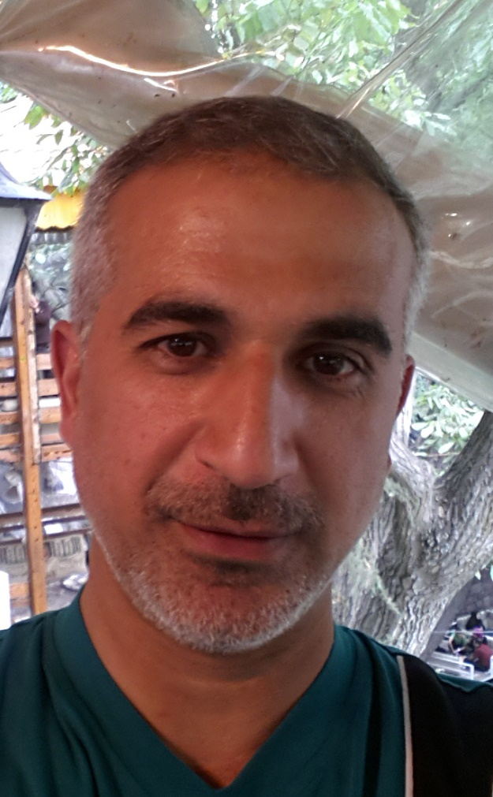

picture

Full Name :Hamid Noori Ali Kamaluldeen
College: Physical Education and Sports Science
Date of Birth:12/8/1974
Marital Status: wedded
Specialization: Physical Education –Motor Learning - Gymnastics
Academic rank: Assistant Professor
Work address: University Of Al-Qadisiyah
E-mail: hamid.ali @qu.edu.iq

Occupation
note | Date obtaining Job | Occupation | NO.
 | 2/11/2013 | The official of the absences unit | 1
 | 26/2/2014 | Graduate Studies Officer | 2
 | 23/10/2016 | R&D unit official | 3

Academic Qualifications (Cetificates)

Date obtained | University | College | Academic qualification
1998 | University of Babil | Physical Education and Sports Science | Bachelor’s degree
15/3/2003 | University of Al- Qadisiyah | Physical Education and Sports Science | Master’s degree
26/2/2012 | University of Al- Qadisiyah | Physical Education and Sports Science | Doctorate
 |  |  | Other

Academic rank:

Date obtained | Academic rank | NO.
30/5/2013 | Assistant lecturer | 1
30/5/2016 | Lecturer | 2
27/11/2013 | Assistant professor | 3
 | Professor | 4

Scientific researches
Date published | Research Title | NO.
2002 | The effect of using a proposed auxiliary apparatus in teaching the skill of bowling on the mind | 1
2012 | An educational curriculum with various methods to develop skills for teaching gymnastic movements after learning and its impact on learning | 2
2013 | The effect of interchangeable and commanding methods on learning some skills  Mobility, consistency, and rendering manual assistance in gymnastics | 3
2019 | The effect of a suggested auxiliary (rotating mind) on teaching the skill of the small back course on the brain system | 4
2017 | Pathway analysis of the compatibility capabilities of the initial performance of male entry and exit skills for students applying for admission to the College of Physical Education and Sports Science | 5
2019 | Analysis of biomechanical variables of the skill of rear fall followed by two straight antennae and 2 laps from the mind device in the men's technical gymnastics to one of the gymnastics heroes in the London 2012 Olympics | 6
2019 | Muscular balance of the upper limbs and trunk and its relationship to the performance of some skills in gymnastics | 7
2019 | The impact of an innovative device for teaching broken rifle defense for young Roman wrestling players | 8
2019 | The effect of a basketball educational program according to (FARC) patterns on some of the motor characteristics of slow learners (6-8) years | 9
2005 | Building standards for some physical characteristics of physical education teachers in Diwaniya | 10
2006 | The psychological hesitation of the gymnasts when performing the front hand jumping skill on the jumping horse | 11
2005 | The effect of the use of grouped and distributed exercise in learning the side and up punches | 12
2006 | Comparing some of the kinematic variables of the skill of standing on the hands under pressure on the parallel apparatus between the Iraqi and the global levels | 13
2012 | The effect of programming special exercises using tools to help students learn the effectiveness of hammer throwing | 14
2013 | Biomechanical feedback to compare the learner's performance with a model on learning to stand in gymnastics | 15
2019 | The effect of an educational program with visual effects on the development of perception, motor alignment, and the accuracy of basketball launch for deaf students | 16
2006 | A comparison between the four advanced teams for the nations of Asia and the four advanced teams for European nations in basketball in the scoring skill for the 2005 season | 17

Published and Translated Books:
Published Date | Book Title | No. النشر

Number of Theses
Number | Supervision | NO.
 | Higher diploma
1 | Masters
2 | Ph.D

Academic Conference, seminars and workshops attended
Kind of participation | place | Date | Title | NO.
lecturer | continuous education | 2017 | Writing a research report | 1
lecturer | continuous education | 2019 | Calculating the player score | 2
lecturer | continuous education | 2019 | Calculating the player score | 3
Sharing | Administration and Economics Hall | 2019 | The first scientific forum for biomechanics | 4
Sharing | Administration and Economics Hall | 2019 | Dynofoot device | 5
Sharing | Administration and Economics Hall | 2019 | Busan apparatus | 6
researcher | Faculty of Physical Education | 2009 | The first scientific conference for biomechanics | 7
researcher | Faculty of Physical Education | 2010 | The Second Scientific Conference of Biomechanics | 8
researcher | Faculty of Physical Education | 2012 | The Third Scientific Conference of Biomechanics | 9
Sharing | Advice Center | 2013 | Educational counseling course | 10
Sharing | Teaching Development Center | 2005 | Educational qualification course | 11
Sharing | Teaching Development Center |  | E-learning technologies course | 12

Permanent and temporary committees
Date | Permanent or temporary | Committee | NO.
2012 | Permanent | Examination committee | 1
11/2/2019 | Permanent | Curriculum Update Committee | 2
21/5/2019 | Temporary | Correction committee | 3
9/1/2019 | Temporary | The committee to object to the annual calendar | 4
22/11/2018 | Temporary | Subscription fees committee (in the forum) | 5
10/10/2018 | Temporary | A committee to audit applicants' priorities as lecturers in the evening | 6
21/6/2018 | Permanent | Electronic Induction Committee | 7
8/1/2018 | Temporary | Postgraduate examination committee | 8
28/12/2017 | Temporary | Study Leave Granting Committee | 9

Other Scientific activities
Kind of activity | NO.
12 | Evaluating Scientific Research
 | Scientific Initiatives
7 | Evaluate Theses
Patent (multi-purpose device in learning the skills of gymnastics | Patent 1
(An auxiliary device in teaching bowing to the Horizantal Bar | Patent 2
 | Contracting with State Institutions

Course Taught
( Master,PhD)postgraduate | Undergraduate | NO.
 | Gymnastics | 1
Motor learning

Voluntary initiatives and actions
Date | Voluntary initiatives and actions | NO.
2019 | Initiative and volunteer work special wrestling hall | 1

Awards, Certificates and Letters of appreciation
Date obtained | Institution Awarded | Awards, Certificates and Letters of appreciation | NO.
2013 | Ministry of Higher Education and Scientific Research | A letter of thanks and appreciation | 1
2013 | University of Qadisiyah | A letter of thanks and appreciation | 2
2014 | University of Qadisiyah | A letter of thanks and appreciation | 3
2014 | University of Qadisiyah | A letter of thanks and appreciation | 4
2015 | University of Qadisiyah | A letter of thanks and appreciation | 5
2018 | Faculty of Physical Education and Sport Sciences | A letter of thanks and appreciation | 6
2019 | Faculty of Physical Education and Sport Sciences | A letter of thanks and appreciation | 7

Languages skills
Level ( Beginner,Inermediate,Advance ) | Language | NO.
professional | Arabic | 1
Beginner | English | 2
 | other | 3

